**Troubleshoot on Azure errors**

1. **Error – Cannot auth to azure: No available subscription found in current azure account**

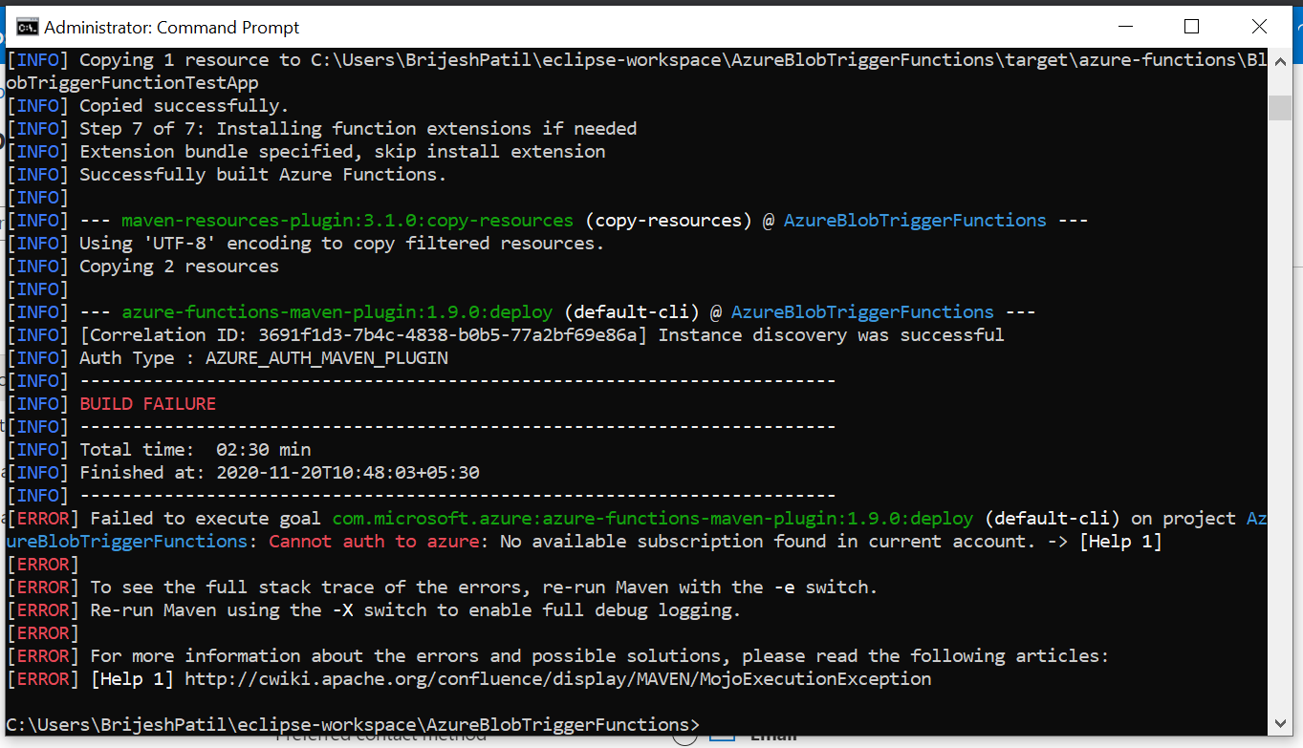

**Solution** :

* Update all details on azure (Like name, address etc)
* Go to location on windows C:\Users\local_admin\.Azure and look for file named azure-secret, delete the file

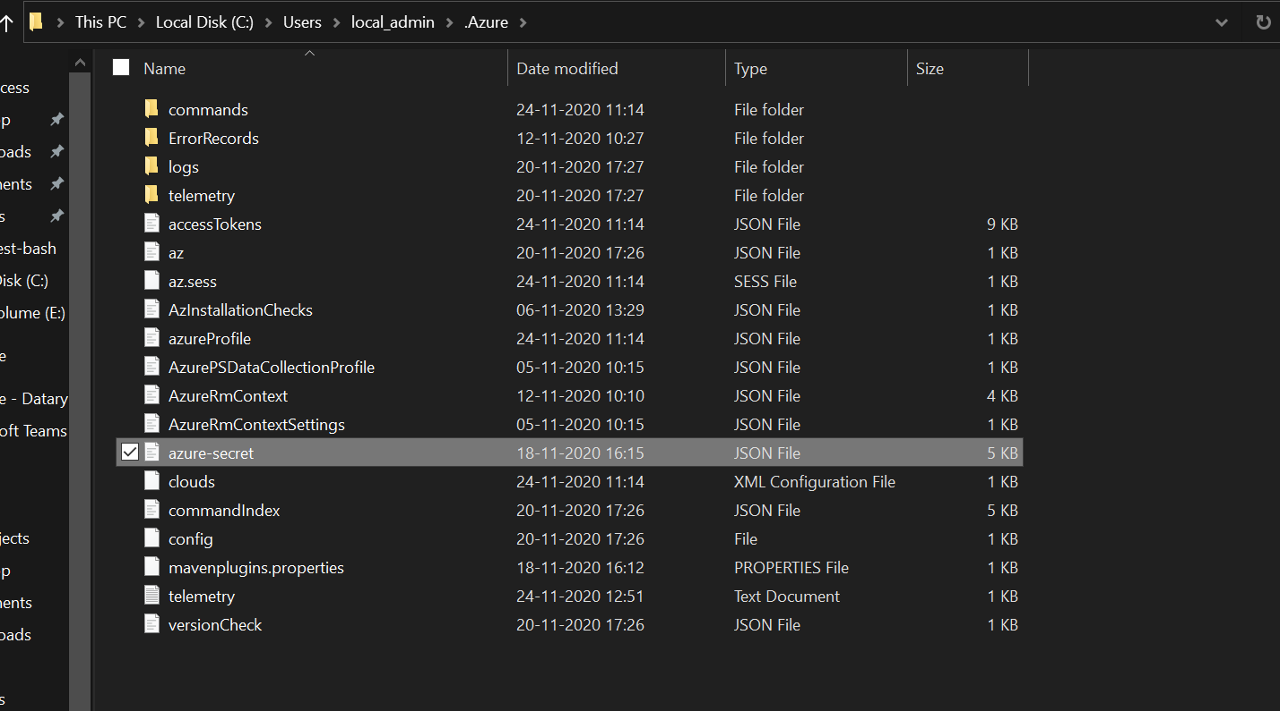

* Then restart to login

1. **Function did not work for unzip and upload to another container**

**Solution:** Use below library

<dependency>

<groupId>com.microsoft.azure</groupId>

<artifactId>spring-starter-azure-storage</artifactId>

<version>1.2.8</version>

</dependency>

1. **Queue trigger not working**

**Solution:**  When we use queue from the storage account we created it’s not working but when we use queue from storage account which gets created when we first deploy function app to azure then it works. (Reason is not known at the movement).